AWS Honeynet – Week 2 Observation Report

📅 Date
2025-12-8: 00:00AM 2025-12-14: 23:30:00.000AM
Document Summary and Table of Contents

This document is a report of the second week of activity of the T-Pot Honeynet following its setup on November 30th at approximately 10:00 AM. By analyzing patterns and significant activity, this report aims to provide insight into peak attack periods, common attack sources, and provide insight into future cyber-attacks.

This report will analyze findings and provide predictions on anticipated trends over the next week, comparing findings to last week’s data.

Key Events:
Potential Honeynet Impact:
- Increased outbound C2-style beaconing behavior
- HTTP(S) requests mimicking legitimate browser user agents
- Credential-harvesting or token validation attempts against exposed web services

4. Public Disclosure of ASUS Third-Party Supplier Breach
Date: Dec 8, 2025
A breach involving leaked firmware and source code from an ASUS supplier was disclosed.
Potential Honeynet Impact:
- Reconnaissance or exploit testing against embedded systems
- Increased scanning for known/default credentials
- Firmware- or device-specific fingerprinting attempts

5. State-Sponsored Backdoor Activity (BRICKSTORM)
Date: Dec 8–10, 2025
Government agencies reported continued use of a Golang-based backdoor targeting enterprise and virtualized environments.
Potential Honeynet Impact:
- Sophisticated reconnaissance patterns
- Lateral-movement-style probing
- Low-and-slow traffic designed to evade detection

6. Ransomware Data Exfiltration via Enterprise Software Vulnerabilities
Date: Dec 9–12, 2025
Ransomware groups exploited critical enterprise software vulnerabilities to steal data prior to encryption.
Potential Honeynet Impact:
- Targeted scanning for enterprise services (Oracle, VMware, file-sharing platforms)
- Increased POST requests and authentication attempts
- Payload delivery attempts following service enumeration

7. Surge in Exploitation of Newly Disclosed CVEs
Date: Dec 11–14, 2025
Multiple high-severity vulnerabilities in web servers, DevOps tools, and Windows services were rapidly weaponized.
Potential Honeynet Impact:
- Sharp increases in automated scanning
- Exploit payloads embedded in HTTP requests
- Rapid shifts in attacker tooling following public CVE disclosure

Key Observational Takeaways
- Traffic spikes during this period may correlate with public vulnerability disclosure timelines.
- A mix of high-volume botnet noise and targeted exploitation attempts is expected.
- Cloud-hosted honeynets may see disproportionate probing due to attacker assumptions about misconfiguration or exposed services.
Let’s get into the Data!
Defining the Top 10 Honey Pots Based on Attacks (As of 12/14/2025)
Analysis & Predictions: Based on my preliminary research and gathered data, I expect Dionaea, HoneyTrap, and Cowrie to continue receiving the highest attack volumes throughout the simulation. Unlike last week, HoneyTrap and Dionaea will likely attract significantly more attacks than the Cowrie Honey Pot. Most attacks directed at Cowrie were in response to the CloudFlare outage on December 5th, which exposed hundreds of thousands of previously inaccessible VMs to VNC and remote vulnerability exploitation. Generally, Cowrie would likely attract less attacks because it requires more interaction and skilled attackers than the resources hosted by the Honeytrap and Dionaea honeypots, which are low skill and high reward targets. Below, I will again list the honeypots in the Honeynet and their purpose.

1). HoneyTrap: 154k (226.47% ↑)

Change: This increase of attacks against the Honeytrap honeypot lines up very well with what was happening in the threat landscape. This week saw multiple high-severity CVEs disclosed and rapidly weaponized (enterprise services, web apps, Windows services). After the disclosure. attackers run broad, untargeted scanners across cloud IP ranges and probe any service that responds or behaves unusually.

Another low-interaction honeypot written to catch attacks against TCP and UDP services. It starts when a connection attempt to a port is made, running as a daemon thread. It provides multiple operation modes that vary the level of defense and analysis the user wants. In normal mode, the server sends the data formatted as a basic template. For a more defensive approach, incoming connections are proxied back to the initiator. Finally, for more of a high-interaction approach, the proxy mode allows the forwarding of sessions to high-interaction honeypots.

2). Dionaea: 137k (5.52%↓)

A widely used, low-interaction cybersecurity tool designed primarily to trap and collect malware samples by emulating vulnerable services across a network and Windows environments. It’s primary purpose to capture the actual malware that binary attackers use in their exploitation attacks. It logs hash values such as MD5 from the files for further analysis and intelligence gathering. It emulates common protocols like SMB, FTP, HTTP, MySQL, SIP, MSSQL to attract attacks that target specific, well-known vulnerabilities. Collected attack logs can be ingested through analysis platforms like Splunk or MHN for visualization.

3). Cowrie: 9k (93.89%↓)

Change:

Another commonly used, cybersecurity tool, Cowrie is a medium to high interaction SSH and Telnet Honeypot which is designed to log brute force attacks and the shell interaction performed by the attackers. It emulates a full UNIX system environment, including a fake filesystem to allow attackers to interact as if they have gained access. It logs brute force attempts, the credentials used, the commands typed during the SSH or Telnet session, the files downloaded/downloaded with wget/curl or SFTP/SCP. Collected data can be integrated with event management software like Splunk of MS Sentinel to provide threat intelligence and alerts. The decrease in attacks

4). Heralding: 7k (350% ↑)
A credentials capturing honeypot. Developed by johnnykv, Heralding captures relevant log data that is split into 3 files: log session data, login authentication data, and log session data. The increase can be attributed to:
- Post-CVE reconnaissance: Following public vulnerability disclosures, attackers commonly perform broad authentication probing to identify weak or reused credentials before deploying exploits.
- Lightweight automation preference: Heralding responds quickly and requires minimal interaction, making it ideal for high-speed scanners and botnets.
- Credential reuse spillover: Supply-chain compromises and malware campaigns often lead to credential dumps, which are rapidly tested at scale across cloud services.

5). TANNER/SNARE: 2k (0%)

SNARE (Super Next Gen Advanced Reactive Honeypot) is a web app honeypot sensor that attracts malicious activity. Events (HTTP requests) in SNARE are sent to TANNER, a remote data analysis and classification service that decides how SNARE should respond to the client.

6). H0neytr4p: 1k

An open-source, easily configurable honeypot designed to protect against web recon and exploitation.

7). Mailoney: 1k (50%↓)

A low interaction SMTP honeypot developed in python that simulates a vulnerable mail server to detect and log unauthorized access attempts.

8). Cisco ASA: 1k

A low-interaction, open-source honeypot designed to detect a DoS and remote code execution vulnerability called CVE-2018-0101.

9). Redis Honey Pot: 617

A security decoy system that mimics a vulnerable/misconfigured Redis (Remote Dictionary Server) instance to attract, detect, and store data on cyberattacks. It supports basic commands like PING GET, and KEYS. Because Redis is a popular in-memory data store that stores cryptocurrency, the Redis Honey Pot is especially useful for analyzing attack patterns and methods to protect against cryptocurrency mining malware and backdoors. A Redis Honeypot alerts security teams to unauthorized scanning and brute force attempts on its ports and logs all client interactions.
Network Traffic Summary
Observations: After analyzing honeynet traffic, it is apparent that most attacks (154,458) were directed against the HoneyTrap honeypot. This accounts for approximately 49% of the overall Honeypot attacks within the 7 days. This is followed by Dionaea, which accounts for (136,092 attacks) 43.6% of overall attacks, and Cowrie, with 8,585 attacks (2.73%).
Analysis: These findings are more consistent with my predictions than last week’s data. It makes sense that Dionaea and HoneyTrap attracted the most attacks because of their low-interaction nature. HoneyTrap logs large-scale scans with tools such as nmap. This allows attackers to scan all open ports with different settings and flags. Dionaea emulates common and high-value protocols such as SMB, FTP, HTTP, MySQL, SIP, and MSSQL

Analysis | Figure
During this 7-day period, attacks seemed to peak daily around 03:00, 12:00, 06:00, and 0:00. These patterns suggest:  1). Business Hours Attack strategy (12:00, 03:00): Consistent with the data from last week, there are daily peaks in attacks during times of peak legitimate usage. 12:00 and 03:00 are times where the most legitimate users are working and suspicious activity is less likely to be noticed. 12:00 is also most workers’ lunch breaks so attackers may intend to capitalize on the reduced monitoring over systems. However, this might change with the increased use of automated monitoring and alert tools  2). Shift Changes (0:00, 6:00): Attackers may be attempting to capitalize on general confusion associated with shift changes, as new personal are less likely to notice attack patterns. A general increase of attacks around 6:00 may indicate that attackers capitalize on after-business hours when IT staff and workers have left the office  Outliers: There seems to be a general increase of attacks over the period of December 9th to the 12th. Looking back over the key tech trends over the December 12-14 period, this increase of attacks may be attributed to various ransomware groups exploiting critical enterprise software vulnerabilities to steal data prior to encryption. This event consists of  - Targeted scanning for enterprise services (Oracle, VMware, file-sharing platforms)  - Increased POST requests and authentication attempts  - Payload delivery attempts following service enumeration  To be able to confirm that the increase of attacks is correlated with these events, we must look over logs related to FTP, HTTPS/HTTP, SMB, and RDP. Most likely these attacks would be targeting the Dionaea honeypot, so over the next couple pages we will pay careful attention to activity on the Dionaea honeypot. | Figure 1: Honeynet Attacks Histogram 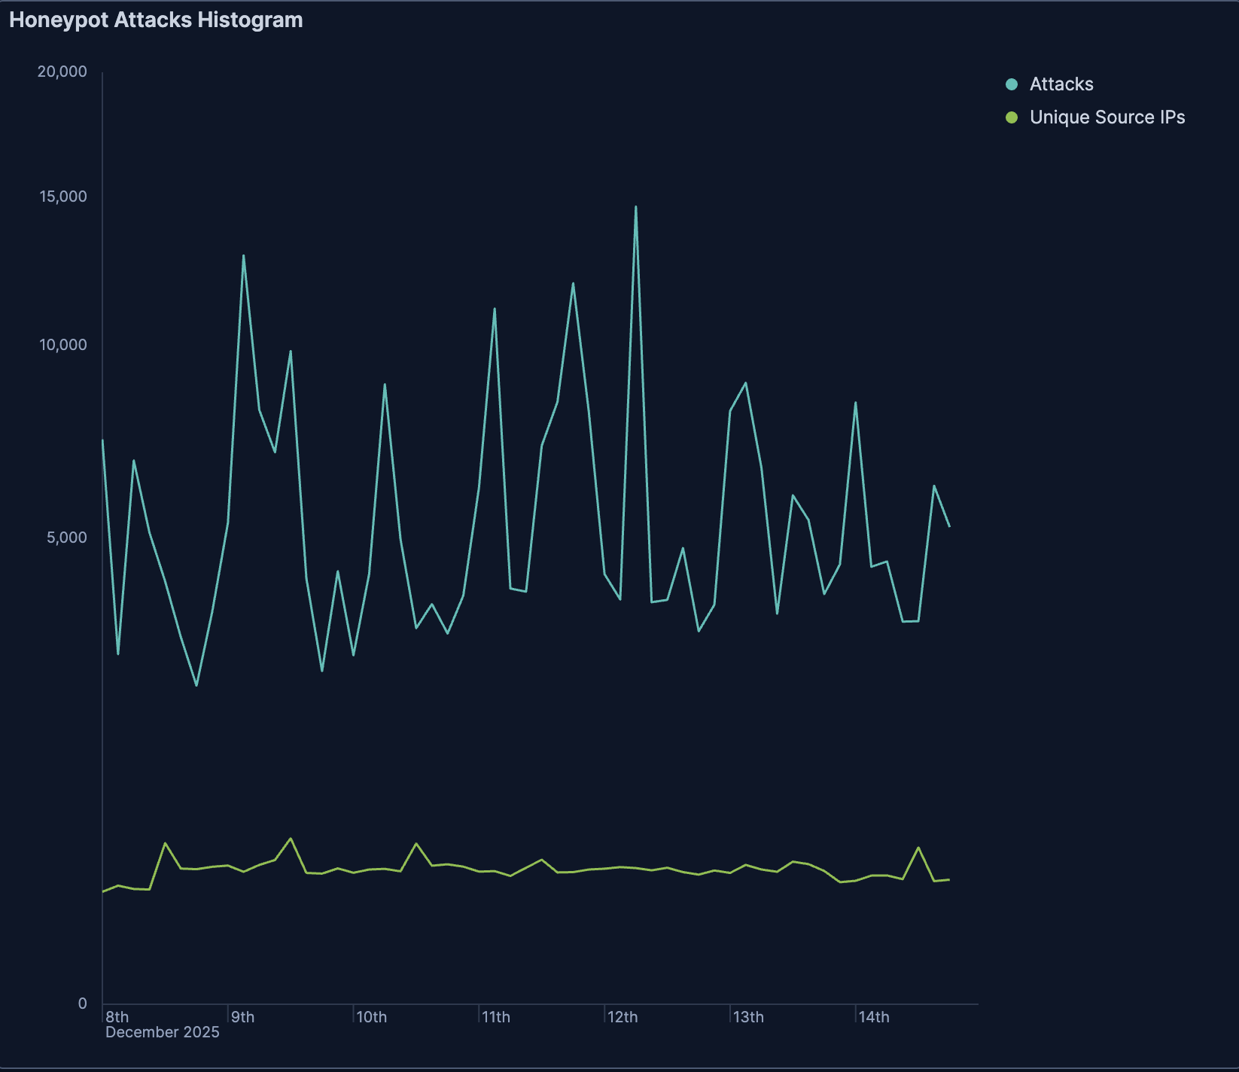
Consistent with my predictions, the Dionaea honeypot exhibits spiking behavior, especially between December 9 at 03:00 and December 12 at 06:00. Although it cannot be for certain, it is extremely likely the increase spike in attacks is due to the increase of ransomware attackers attempting to exploit vulnerabilities in enterprise software before they can be encrypted. Otherwise, The traffic is quite consistent with last week’s data, with the exception of there being a decrease in attacks against the Cowrie honeypot, which experienced a huge spike in attacks due to the Cloudflare outage on December 5th. Much like last week, attacks against the Dionaea honeypot tend to spike during strategic times of the day, indicating that attackers deploy large scans through tools like nmap to scan many ports. This can also be observed with most of the other honeypots, with the exception of Honeytrap. Much like last week, Honeytrap receives consistent numbers of attacks. This is because Honeytrap captures generic connection attempts such as internet noise, mass scan sweeps, and continuous scanning. Because there are always automated scanners that sweep between the IPv4 space 24/7, globally, and continuously, Honeytrap attackers don’t exhibit the same spiking behavior that other honeypot attackers do | 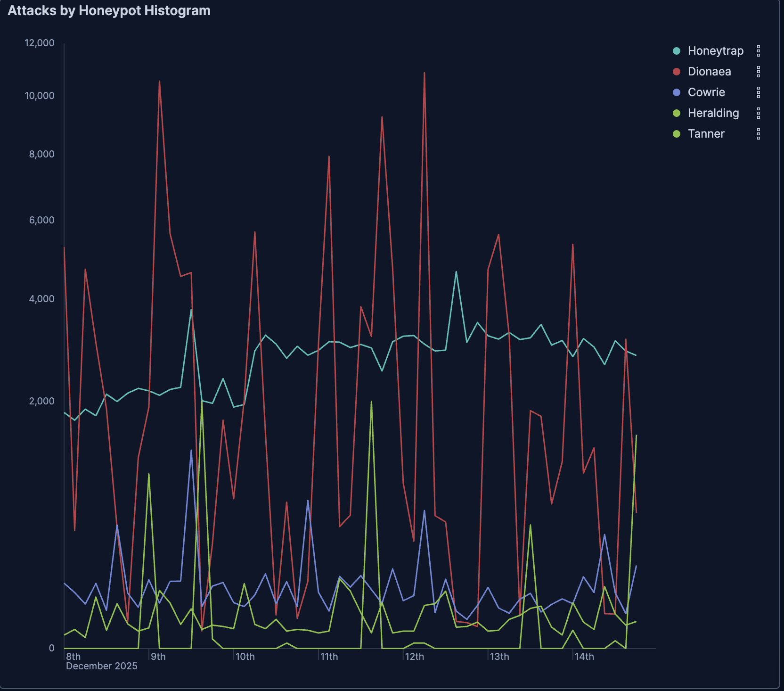  Figure 2: Attacks by Honeypot Histogram
On immediate inspection, it appears that there are several large spikes around the 11th to 13th. India has a massive spike around ~9k attacks from the 11th to 12th, Iran has repeated sharp vertical spikes, and South Korea had a general increase in attacks after the 10th. With these types of graphs, sharp vertical lines usually indicate  - automated scanning bursts  -worm propagation  -Botnet task pushes  -Infrastructure clusters activating simultaneously  Looking specifically at the India spike, it is apparent that it spikes sharply and drops quickly, which is a likely indication of command-and-control behavior, where a cluster of compromised hosts receive a command update and scanning aggressively for a short period of time. This is very typical behavior for VPS botnets, IoT botnets, and worm propagation from a subnet. This general uptick aligns quite strongly with Dionaea traffic patterns. Because Dionaea emulates SMB, FTP, HTTP, SIP, and other worm targets, it’s likely that a botnet controller pushed a new exploit module. To validate this, we should check if many IPs share the same ASN, look at payload similarity, connection duration, and compare port targeting. See the next section | 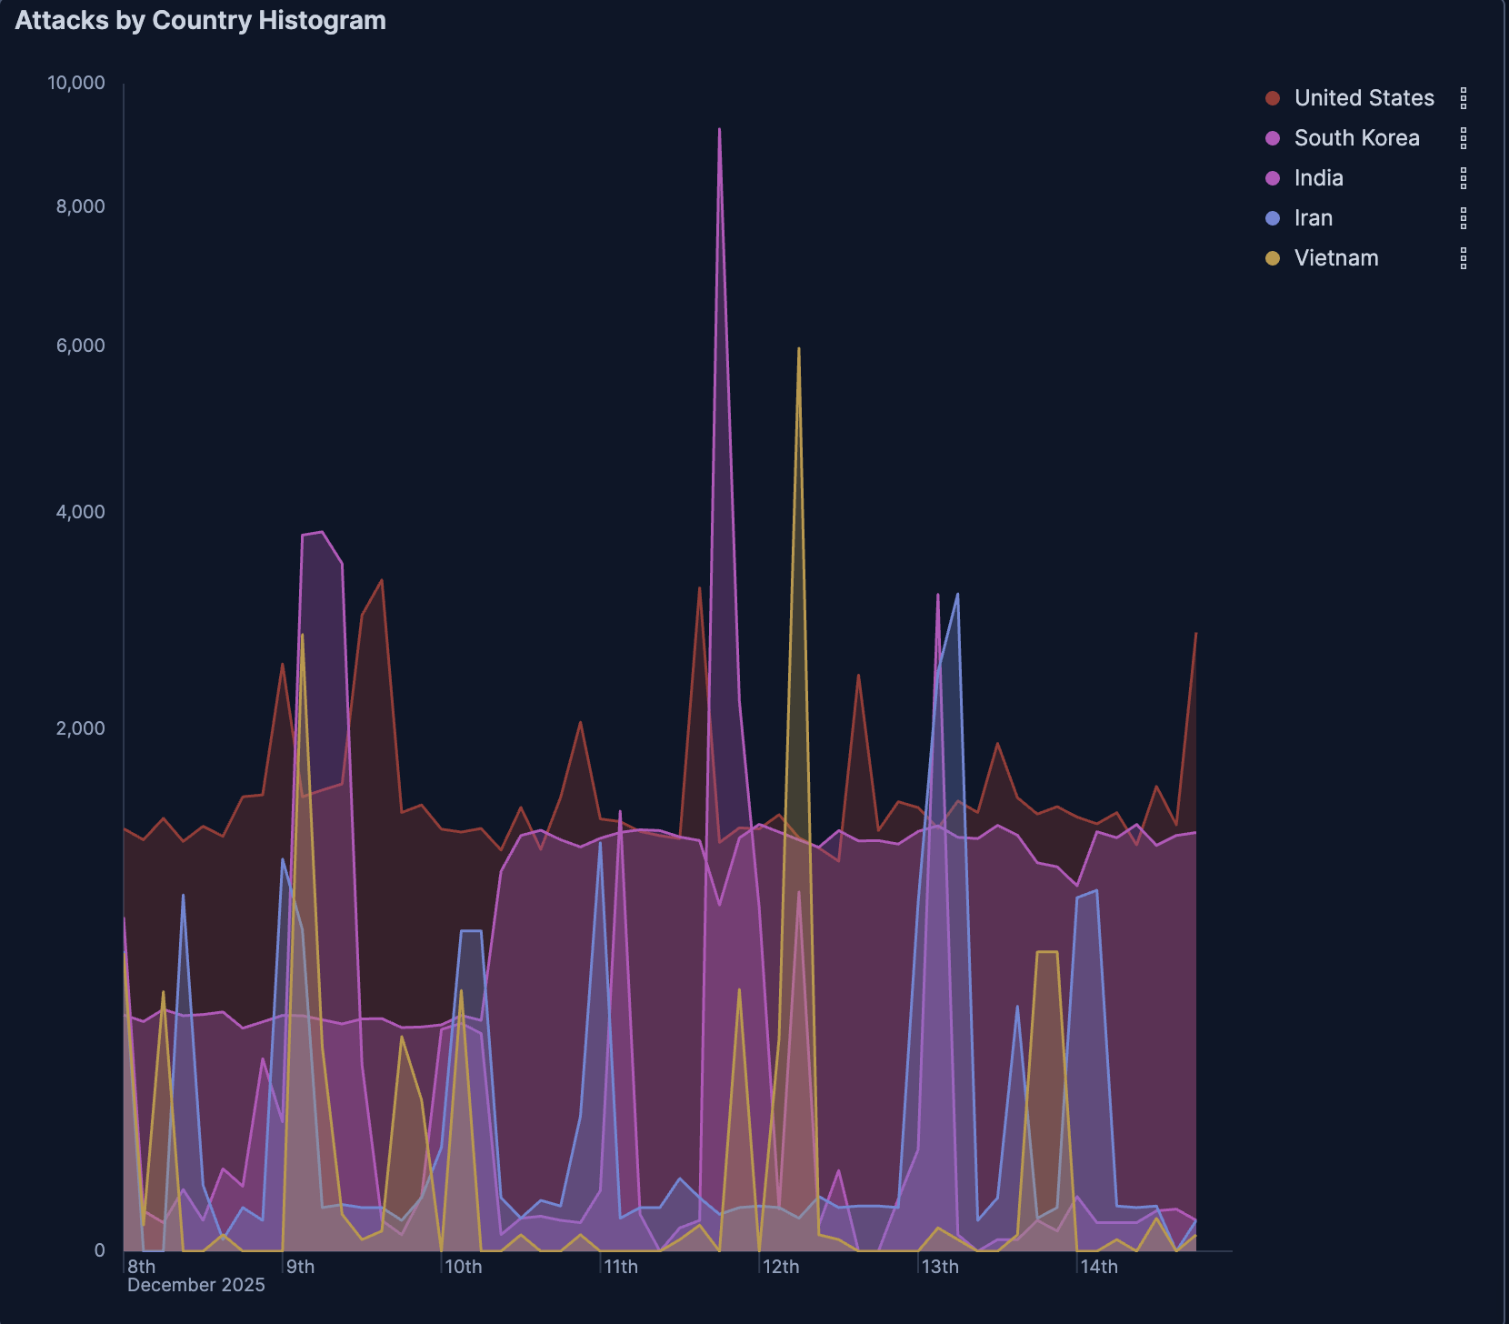  Figure 3: Attacks by Country Histogram
Consistent with last week’s findings, port 445 remains the most attacked destination port. These findings are consistent with the spike in Dionaea attacks, which hosts SMB targets. The spike in SMB attacks is sustained from December 9th to the 12th. Interestingly, most of the other commonly attacked ports sustained a consistent number of attacks a day, which sharply contrasts Dionaea’s sporadic behavior. Commonly attacked ports include 5920, 5925, 5900, and 5921, non-standard protocols that are often used for unofficial services, specialized applications, or potential malware communication. While 5900 attacks appears in bursts, indicating that the attacks are likely automated and set to a certain time of day or trigger, the other non-standard ports are likely constantly being surveyed by bots. | 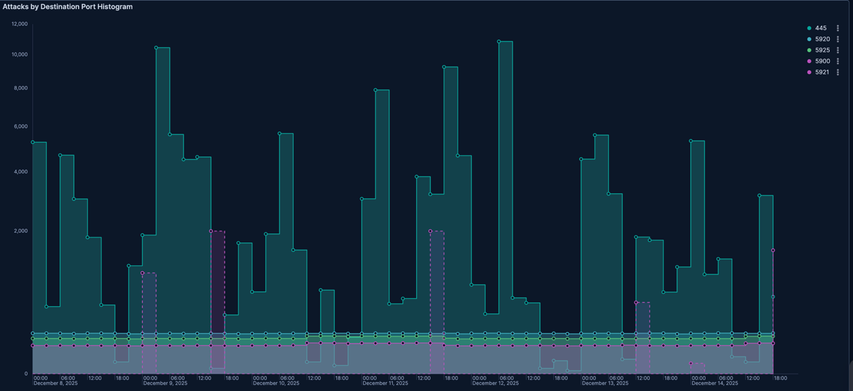  Figure 4: Attacks by Destination Port Histogram
Most attacks seem to occur in the United States, Western Europe, and Southeast Asia. This is consistent with last week’s findings. It does make sense that North America is a hotspot for attacks, since it holds 46% of the world’s virtualized infrastructure. This means that most attacks will likely be centered towards North American virtual datacenters. Per the findings from other figures, it seems most of the attacks originate from Southeast Asia, which is confirmed by the red dots. | 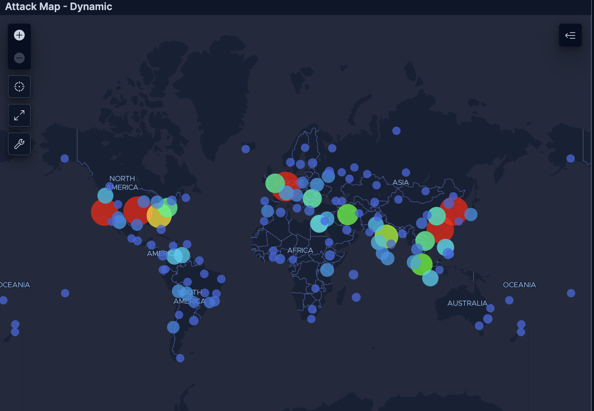  Figure 5: Dynamic Attack Map
Top 10 Countries by Attack Percentages:  1.United States ~35%  It makes sense that the United States is the largest source of attacks. This likely reflects the huge number of internet-connect devices, massive cloud infrastructure, and botnet-infector consumer devices. This is very consistent with the attack map shown in the figure 5  Interestingly, most of the rest of the top 10 attack sources by country is in Asia. This can likely be explained by a high botnet distribution across high-density internet regions such as India, compromised hosting environments, and possible scanning campaigns that target specific regions. This may also mean that the telemetry source is biased toward the Asia-Pacific region, attack campaigns are regionally focused, or sensors are closer to APAC targets  2.South Korea ~21%  3.India ~13%  4.Iran~6%  5.Vietnam~5%  6. Venezuela, Indonesia, Egypt, Singapore, Philippines  To confirm these findings, we must analyze AS/N and IP addresses of attackers. | 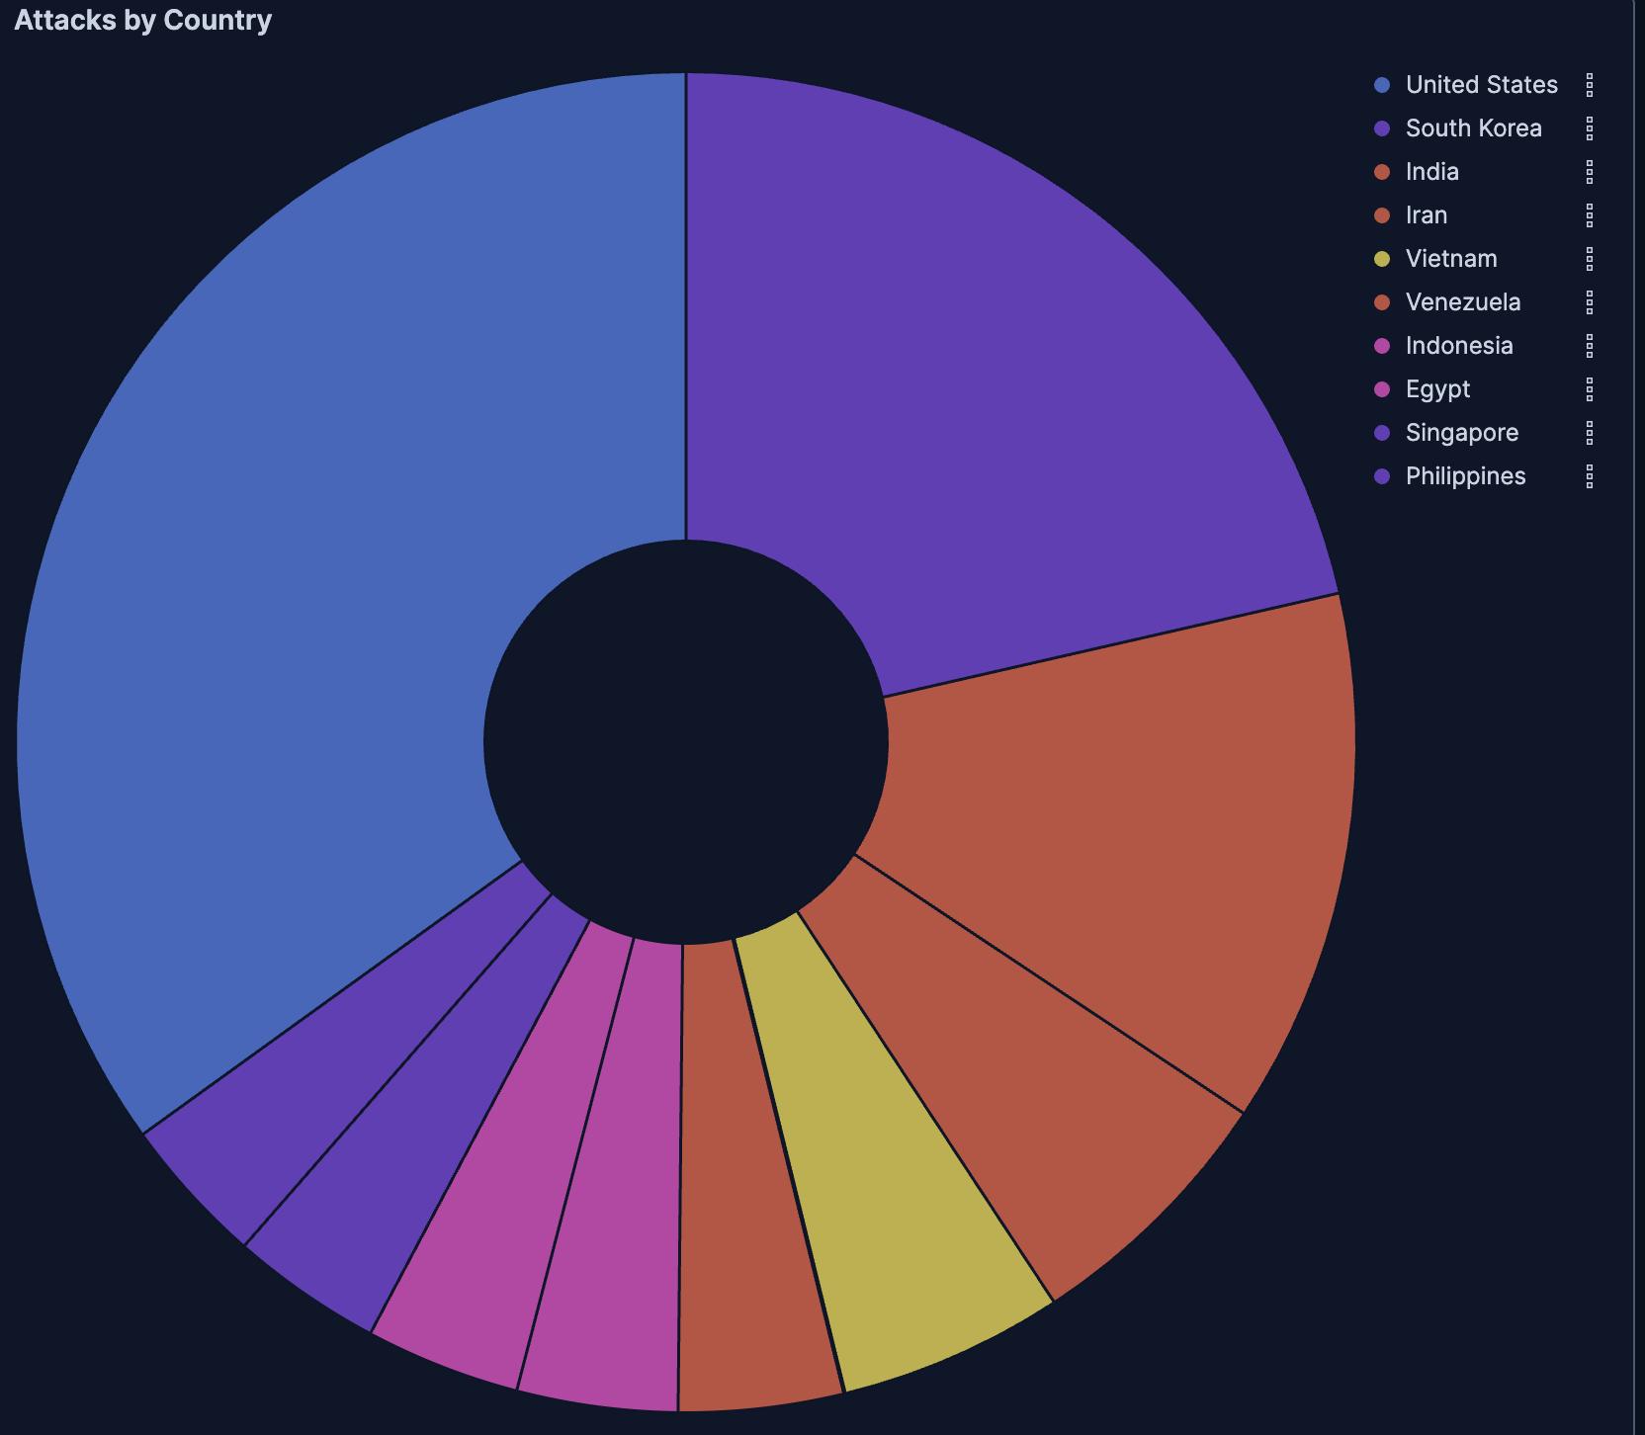  Figure 6: Attacks by Country
United States:  The variation of targeted ports suggests a combination of mixed scanning, opportunistic attack strategies, or generic internet noise. These findings suggest botnet activity, port sweeps, and broad recon instead of hyper-targeted attacks. In order to confirm this, we can run nmap or other reconnaissance scans on the various honeynet ports to see if those scans are considered as “attacks”. This is quite contrasting to the data from last week, where most attacks were targeted towards the SSH protocol (port 22), and SMB (port 445) due to the CloudFlare outage and exemplifies targeted attack patterns.  India, Iran, Vietnam:  India, Iran, and Vietnam mainly attacked port 445. This indicates SMB scanning, worm-style propagation attempts, and exploit attempts that are similar to EternalBlue0type behavior. This may also include lateral movement probing. These all indicate a coordinated SMB-focused campaign, where botnet nodes are spread globally, but use the same malware family, exploit script, and scanning behavior to target port 445.  If this was real production telemetry, I would immediately investigate whether the inbound attempts were to exposed 445 ports, if there were successful handshakes, and if there was internal lateral movement.  During the period surrounding the Cloudflare outage and concurrent ransomware campaigns, there was a significant spike in SMB (port 445) scanning activity across multiple geographic source regions. This may indicate opportunistic reconnaissance targeting exposed Windows services during a period of infrastructure disruption and increased vulnerability exploitation activity. Further time-series analysis is required to confirm sustained campaign behavior. | 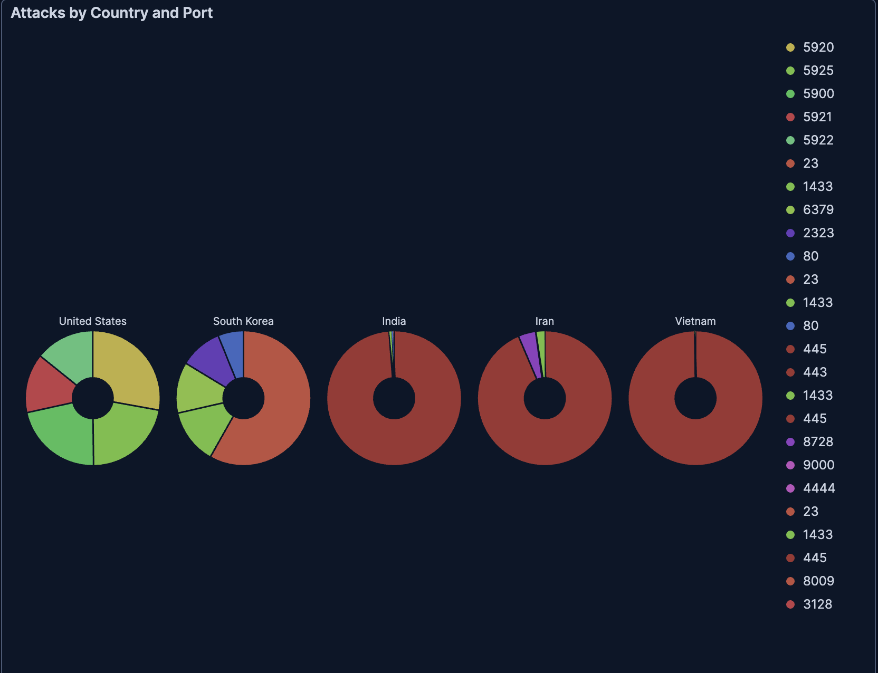  Figure 7: Attacks by Country & Port
It also appears that most of the attacks originate from a known attackers and mass scanners, indicating that many attackers are repeat offenders. While “known attacker” doesn’t indicate specifically indicate that a hacker is personally attacking, it does indicate it has appeared in threat intelligence feeds, or may be tied to malware infrastructure, C2 servers, or past campaigns. The mass scanner designation is behavior-based, and is assigned based on the ports that were scanned. | 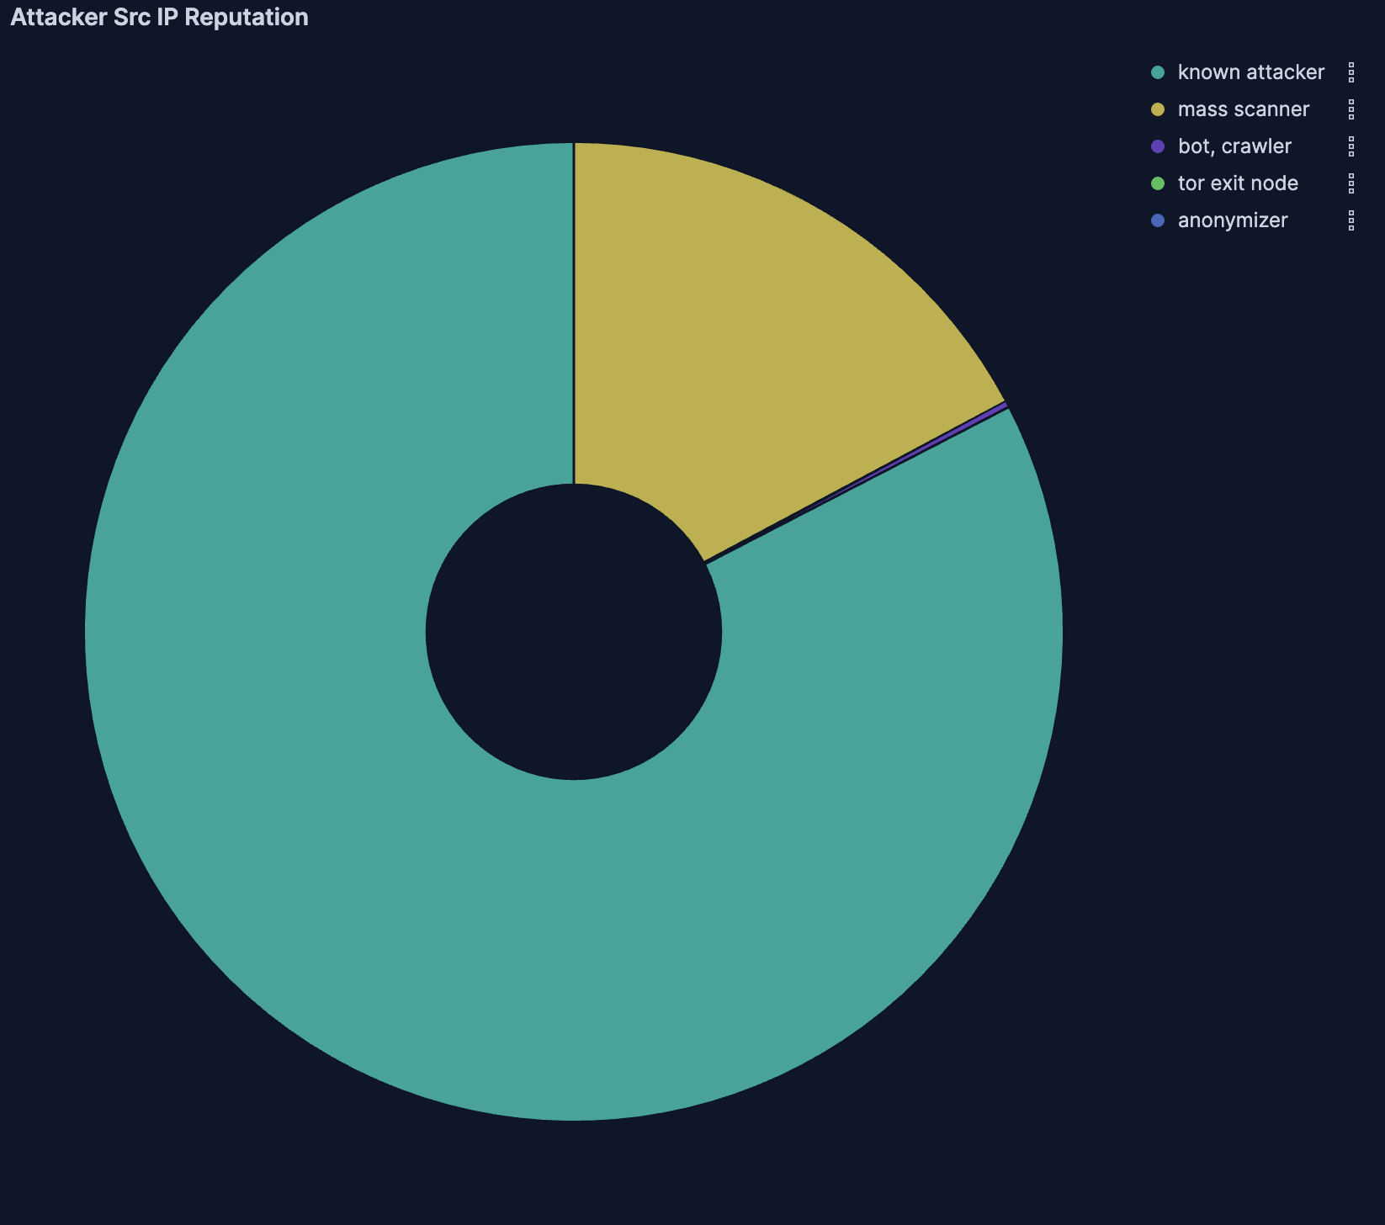  Figure 8: Attacker Source IP Reputation

